# **Final Task Specification Computer Network 2021/2022**

## **1.1** **TCP Simulation on Mininet**

The topology that is used in this scenario can be seen in Figure 12.1.

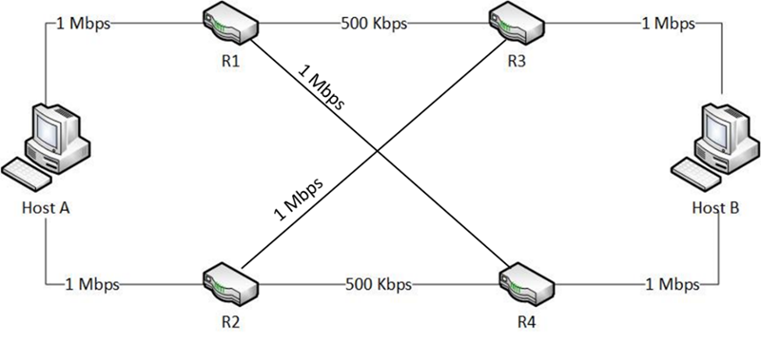Gambar 12.1 Topologi untuk tugas besar

**1)** **CLO 1**

In this CLO, there are work specifications and assessment criteria to be carried out.

* **Goal :** Build topology according to the problem.
* Design subnet for each network.
* Assign IP address based on subnet.
* Test connectivity using ping between 2 hosts that are on the same network.
* **The assessment that will be carried out are :**
* Suitability of the topology built with the given question (30).
* Accuracy of the explanation (50).
* Connectivity between 2 hosts that are on the same network (20).
* TOTAL VALUE = 100.

**2)** **CLO 2**

In this CLO, there are work specifications and assessment criteria to be carried out.

* **Goal :** Implementing the routing mechanism to the existing topology.
* Test connectivity using ping between all hosts.
* Create a routing table for all hosts, proven by ping between hosts.
* Analyze the routing used using traceroute.
* **The assessment that will be carried out are :**
* Accuracy of implemented routing based on specification (30).
* Accuracy of the explanation of the implemented routing process (50).
* Connectivity between hosts that are not in the same network (20).
* TOTAL VALUE = 100.

**3)** **CLO 3**

In this CLO, there are work specifications and assessment criteria to be carried out.

* **Goal :** To Prove that TCP has been implemented correctly in the topology.
* Generate traffic using iPerf.
* Capture traffic using custom script or Wireshark to be inspected, proven by traffic in wireshark/tcpdump.
* **The assessment that will be carried out are :**
* Accuracy of the TCP implementation (40).
* Accuracy of the explanation of TCP and what is the difference between TCP and UDP. (60).
* TOTAL VALUE = 100.

**4)** **CLO 4**

In this CLO, there are work specifications and assessment criteria to be carried out.

* **Goal :** Inspect queue usage on network routers.
* Generate traffic using iPerf.
* Set buffer size on router : 20, 40, 60 and 100.
* Capture the effect of buffer size on delay.
* Analyze the experiment results of variations in buffer size.
* Students understand how to change the buffer size and its effect.
* **The assessment that will be carried out are :**
* Accuracy of buffer size manipulation. (40).
* Accuracy of the analysis of the effects of buffer size manipulation (60).
* TOTAL VALUE = 100.

## **1. 2** **Ketentuan Pengumpulan Tugas Besar**

The collection of this final task has important provisions, there are :

1. Create a final task report which is uploaded on the LMS.
2. Record a demo of the result of a final task with a maximum duration 15 minutes, upload the recording on each YouTube channel. (Faces are required to be shown when recording and explaining demos).
3. Include a youtube recording link on the LMS.
4. Submit the task repost and programs code on the form, maximum at D-1 presentation at 23.59. (form link will be updated)

**1.3** **Presentasi Tugas Besar**

Final Task presentation will be carried out in the 14th week according to the computer network practicum schedule.

**1)** **CLO 1**

* Suitability of the topology built with the given question (30).
* Accuracy of the explanation (50).
* Connectivity between 2 hosts that are on the same network (20).
* TOTAL VALUE = 100.

**2)** **CLO 2**

* Accuracy of implemented routing based on specification (30).
* Accuracy of the explanation of the implemented routing process (50).
* Connectivity between hosts that are not in the same network (20).
* TOTAL VALUE = 100.

**3)** **CLO 3**

* Accuracy of the TCP implementation (40).
* Accuracy of the explanation of TCP and what is the difference between TCP and UDP. (60).
* TOTAL VALUE = 100.

**4)** **CLO 4**

* Accuracy of buffer size manipulation. (40).
* Accuracy of the analysis of the effects of buffer size manipulation (60).
* TOTAL VALUE = 100.